COMMUNITY AND SPECIAL SCHOOLS: A JOURNEY OF INCLUSION

A COMMUNITY CONNECT PROJECT REPORT
Submitted by

AFEEF AHEMD SHAIK (RA2311026050166)
In Partial Fulfillment of the Requirements for the Degree of

BACHELOR OF TECHNOLOGY
in

COMPUTER SCIENCE AND ENGINEERING WITH SPECIALIZATION IN ARTIFICIAL INTELLIGENCE AND MACHINE LEARNING


SCHOOL OF COMPUTING
FACULTY OF ENGINEERING AND TECHNOLOGY SRM INSTITUTE OF SCIENCE AND TECHNOLOGY TIRUCHIRAPPALLI – 621105

July 2025


SRM INSTITUTE OF SCIENCE AND TECHNOLOGY

TIRUCHIRAPPALLI

TIRUCHIRAPPALLI
COLLEGE OF ENGINEERING AND TECHNOLOGY

BONAFIDE CERTIFICATE

Certified as the bonafide record of work done by AFEEF AHEMD SHAIK (RA2311026050166) of 5TH SEMESTER/3RD YEAR, B.Tech. COMPUTER SCIENCE AND ENGINEERING WITH SPECIALISATION IN ARTIFICIAL INTELLIGENCE AND
MACHINE LEARNING Programme in the project-based course 21GNP301L, Community Connect
at SRM Institute of Science and Technology, Tiruchirappalli during the Academic Year 2024-2025.

Faculty In-charge Head of the Department

Submitted for the End Semester Examination held on 29TH JUY 2025

Examiner 1 Examiner 2

CERTIFICATE FROM NGO

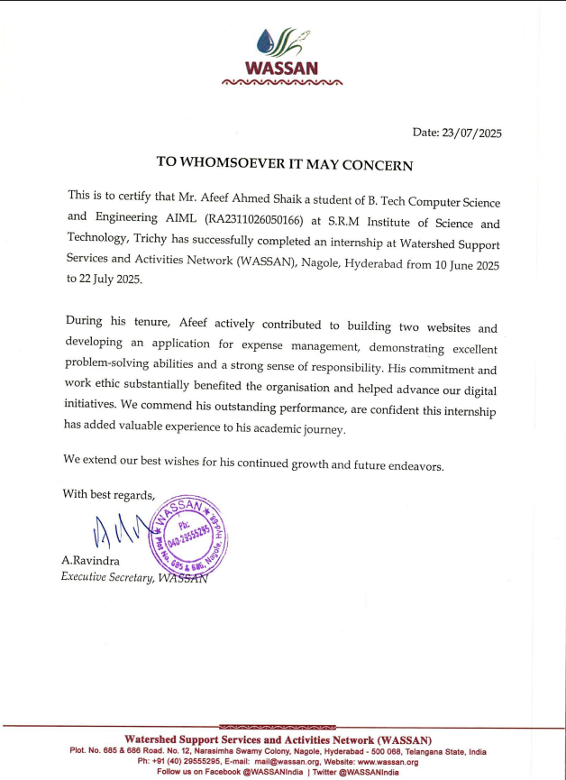
PROBLEM STATEMENT

Rural agricultural communities and NGOs such as the Wassan Foundation face multiple critical challenges that inhibit efficient resource management and hinder impactful community engagement. The key problems identified through fieldwork and surveys are as follows:

Manual Bill Processing and Record Keeping:
  - Existing systems rely heavily on manual data entry and paperwork.
  - This leads to inefficiencies, increased chances of errors, delays in expense tracking, and limited transparency in financial management.
Limited Digital Presence:
  - The NGO currently has minimal digital platforms to promote sustainable agricultural practices and natural farming.
  - This restricts outreach to a broader audience including rural and urban communities interested in environmentally conscious farming.
Lack of Accessible Educational Platforms:
  - Farmers and community members lack easy access to platforms that educate on chemical-free living and sustainable agricultural methods.
  - This creates a knowledge gap and limits wider adoption of sustainable practices.
Time-Consuming Administrative Tasks:
  - NGO staff and volunteers spend significant time on manual administrative activities which reduce their capacity to engage in core programmatic work.
  - User stories reveal repeated frustrations related to inefficient workflows impacting overall organizational productivity.
Inadequate Integration of Data Systems:
  - Separate, unintegrated systems make it difficult to consolidate data for reports, monitoring, and decision-making purposes.
  - This disjointed data management also hampers transparency and accountability.
The target user base impacted by these challenges includes:
- Wassan Foundation staff and administrative personnel.
- Rural farmers and natural farming practitioners seeking support and knowledge.
- Urban communities aspiring towards sustainable living.
- Researchers and organizations focused on agricultural sustainability.

These issues currently affect over 500 direct users including NGO staff and partner organizations, and indirectly impact more than 10,000 community members through improved resource management and agricultural support systems.

If unaddressed, these challenges will continue to constrain the NGO's operational efficiency, limit community engagement, and reduce the effectiveness of sustainable agriculture promotion. Therefore, the development and deployment of integrated digital solutions are essential to empower the Wassan Foundation to overcome current inefficiencies and expand its positive influence on rural and urban communities alike.

TABLE OF CONTENTS

CHAPTER NO. | TITLE | PAGE NO.
 | PROBLEM STATEMENT | 4-5
 | LIST OF FIGURES | 7
 | LIST OF ABBREVIATIONS | 8
1 | INTRODUCTION | 9
 | - 1.1 Introduction | 9 – 10
 | - 1.2 Level of Innovation | 10 – 12
 | - 1.2.1. Conceptual Novelty | 10 – 11
 | - 1.2.2. User-Centered Design | 11 – 11
 | - 1.2.3. Programmatic Integration | 11 – 12
 | - 1.2.4. Measurable Impact and Evidence | 12 – 12
 | - 1.2.5 Scalability and Replicability | 12 – 12
 | - 1.2.6 Risk Management and Adaptability | 12 – 12
 | - 1.3 Community Work and the NGO | 12 – 13
 | - 1.4 Milestones and Timeline | 13 – 15
2 | DESIGN AND DEVELOPMENT | 16 – 24
 | - 2.1. TECHNICAL IMPLEMENTATION | 16 – 20
 | - 2.2. DELIVERABLES | 20 – 22
 | - 2.3. BUDGET | 22 – 23
 | - 2.4. IMPACT ASSESSMENT PLAN | 23 – 24
3 | CONCLUSION AND FUTURE WORK | 25 – 26
 | - CONCLUSION | 25 – 25
 | - FUTURE WORK | 25 – 26
4 | APPENDICES AND REFERENCES | 27 – 32
 | - APPENDICES | 27 – 31
 | - REFERENCES | 32 – 32

LIST OF FIGURES

FIGURE NO. | TITLE | PAGE NO.
1 | OCR APP INTERFACE | 15
2 | OCR APP INTERFACE | 15
3 | OCR APP AUTO EXCEL SHEET | 17
4 | MAA NAVA INTERFACE | 19
5 | MAA NAVA INTERFACE | 19
6 | MAA NAVA CODE | 22
7 | WASSAN FOUNDATION INTERFACE | 23
8 | WASSAN FOUNDATION INTERFACE | 23
9 | WASSSAN FOUNCDATION CODE | 25

LIST OF ABBREVIATIONS

API | - | Application Programming Interface
CSV | - | Comma Separated Values
GIS | - | Geographic Information System
GPS | - | Global Positioning System
IoT | - | Internet of Things
NGO | - | Non-Governmental Organization
PNG | - | Portable Network Graphics
SDG | - | Sustainable Development Goals

CHAPTER 1 INTRODUCTION

INTRODUCTION

Sustainable agriculture and community development are fundamental components of long-term rural progress, particularly in regions dependent on rainfed farming. Non-Governmental Organizations like Wassan Foundation play a pivotal role in empowering rural communities through natural farming, environmental conservation, and livelihood improvement initiatives. However, many NGOs face operational inefficiencies due to outdated processes, limited digital presence, and insufficient knowledge dissemination tools. This project was conceived to address these challenges by developing innovative, technology-driven solutions that enhance organizational efficiency and expand community outreach. Through digital platforms, the project aims to simplify financial management, foster transparent data handling, and provide educational resources for promoting chemical-free farming and sustainable lifestyle practices. Field research and collaboration with Wassan Foundation staff revealed a strong demand for automation and accessible digital tools to better manage administrative functions and engage diverse stakeholders. The project aligns with the NGO’s mission of promoting responsible agriculture and environmental awareness, reflecting broader goals of social empowerment, sustainability, and technological inclusion at the grassroots level.

OBJECTIVE:
The primary objective of this project is to develop and implement integrated digital solutions that enhance the operational efficiency and community outreach capabilities of the Wassan Foundation, thereby supporting sustainable agriculture and natural farming practices. This includes automating manual financial processes through an OCR-based bill management system, strengthening the NGO’s digital presence with a responsive community website, and providing accessible platforms for education on chemical-free living and environmental conservation. The project aims to empower NGO staff, rural farmers, and urban communities by facilitating streamlined workflows, transparent resource management, and widespread dissemination of sustainable agricultural knowledge. Ultimately, these efforts seek to improve organizational productivity, increase community engagement, and contribute to the broader goals of environmental sustainability and social empowerment within the target regions.

SCOPE:
The scope of this project encompasses the design, development, and implementation of digital solutions aimed at improving the operational framework of the Wassan Foundation while expanding its outreach in promoting sustainable agricultural practices across rural and urban communities. The project includes creating a bill management web application for automating financial workflows, developing a responsive website for community engagement and awareness on sustainable living, and redesigning the NGO’s primary website to enhance transparency and accessibility. These interventions are intended to modernize administrative processes, reduce redundancy, and enable seamless data integration for efficient decision-making. The scope further extends to capacity-building initiatives such as staff training, documentation, and deployment support to ensure the NGO’s independence in system maintenance. However, the current phase excludes the implementation of AI-based predictive tools and mobile app extensions, which are reserved for future upgrades. Overall, the project scope covers the end-to-end technological transformation necessary to strengthen the NGO’s digital infrastructure, community participation, and sustainability-driven program delivery.

MOTIVATION:

The primary motivation behind this project stems from the growing need to empower non-profit organizations like the Wassan Foundation through digital transformation. Field interactions revealed that manual administrative work, limited technology adoption, and fragmented communication systems were restricting the NGO’s outreach and operational efficiency. As global trends increasingly shift toward digital ecosystems, adopting technology-driven solutions becomes essential to modernize workflows, enhance transparency, and build sustainable community engagement models. The objective is to enable NGOs to focus more on their core mission supporting natural farming and sustainable living—by reducing time spent on repetitive administrative tasks. Through this project, the team seeks to bridge the digital divide in the non-profit sector by introducing tools that simplify processes, improve data-driven decision-making, and strengthen collaboration between staff, volunteers, and the community.
CHAPTER 2 TECHNICAL APPROACH
The PeyyumMazha GIS-Based Rainfall Mapping System adopts a systematic, structured technical approach to convert rainfall data into visually interpretable spatial maps through Python programming and GIS frameworks. The process begins with data ingestion, where rainfall data containing geographic coordinates (latitude and longitude) and rainfall measurements are collected from reliable CSV or Excel sources. This ensures that each rainfall data point is georeferenced accurately, enabling precise placement on the geographic grid during map generation. The next stage involves grid generation using numpy to create a structured mesh grid over the region of interest, allowing uniform sampling of the spatial domain and facilitating accurate interpolation of rainfall values across unsampled locations. Following grid generation, spatial interpolation is performed using the scipy.interpolate.griddata method, employing linear or cubic interpolation to estimate rainfall intensities at each grid cell based on surrounding data points, thereby creating a smooth and continuous rainfall distribution surface across the mapped region.

After interpolation, the system advances to the visualization stage, utilizing matplotlib and cartopy to overlay the interpolated rainfall data on the Kerala basemap, including district boundaries and coastlines for contextual understanding. The visualization is further enhanced using color maps that represent different rainfall intensities, making it easier for stakeholders to distinguish between heavy, moderate, and light rainfall zones. Finally, the system includes a map exporting module, where the generated rainfall maps are saved in high-resolution image formats such as PNG or JPEG, enabling their use in reports, presentations, research analysis, and integration with other monitoring tools. This systematic approach ensures that the rainfall mapping process is automated, accurate, and scalable while maintaining flexibility for adjustments in grid resolution, color schemes, and input data, making it a valuable engineering solution for rainfall monitoring.

CHAPTER 3 SYSTEM ARCHITECTURE
The system architecture of the proposed digital solutions for Wassan Foundation is designed to be modular, scalable, and user-friendly, enabling seamless integration of various functional components while ensuring security and maintainability. At the core is a cloud-based server infrastructure that hosts the web applications, database management systems, and third-party API integrations. This cloud backend supports real-time data processing and storage, allowing for efficient management of bills, expenses, and user interaction data. The server exposes secure RESTful APIs that facilitate communication between front-end clients and backend services, providing flexible endpoints for different application modules.
The front end of the system is implemented as responsive web applications optimized for varied device form factors, including desktops, tablets, and smartphones. The bill management module utilizes Optical Character Recognition (OCR) technology to automate the capture and processing of bill images, which are then synchronized with Google Sheets using the Google Sheets API for collaborative financial tracking. The community engagement portals are developed with modern web frameworks that support interactive content delivery, user authentication, and role-based access control to safeguard sensitive NGO data. The architecture also supports modular software updates and rollout of new features without disruption to ongoing operations.
Security considerations are embedded throughout the system architecture, including encrypted data transmission using HTTPS protocols, secure API keys management for external service integrations, and multi-factor authentication for users accessing administrative modules. Data redundancy and backup mechanisms are implemented to safeguard against data loss, while monitoring tools provide logging and alerting to track system health and usage patterns. This architecture ensures that the digital platform remains robust, scalable, and adaptable to future needs as the Wassan Foundation expands its digital initiatives and community impact.

CHAPTER 4

TECHNICAL MODULES IMPLEMENTED

The project for Wassan Foundation involved the development and integration of multiple technical modules aimed at addressing key operational needs and enhancing community engagement. The centerpiece of the solution is the Bill Management Module, which automates the capture, processing, and tracking of financial documents. Leveraging Optical Character Recognition (OCR) technology, this module extracts text from scanned bills and invoices, converting them into a structured digital format. The extracted data is then synchronized with a collaborative Google Sheets backend, enabling real-time expense tracking and reducing manual errors significantly.

Complementing the bill management system is the Community Website Module, designed to serve as an interactive platform for stakeholders, including farmers, NGO staff, and urban supporters of sustainable agriculture. Built using modern responsive web frameworks, this module supports user authentication, dynamic content delivery, and integration with social media channels for broader outreach. Its mobile-friendly design ensures accessibility across various devices, facilitating continuous engagement regardless of location or connectivity constraints.
The third significant module is the Wassan Foundation Website Redesign, which focuses on improving the NGO’s digital presence and communication capabilities. This module entails restructuring the website architecture for optimized navigation, integrating streamlined donation and volunteer sign-up systems, and embedding educational resources related to natural farming and environmental conservation. The redesign prioritizes user experience, making it easier for visitors to find information and participate in the foundation’s initiatives.

To ensure smooth operation, a Role-Based Access Control (RBAC) module was implemented to regulate user permissions across all modules. This system assigns different access levels to administrators, staff, volunteers, and general users, thereby protecting sensitive financial data and operational controls while facilitating appropriate collaboration. The RBAC module interfaces seamlessly with the authentication framework, supporting multi-factor authentication for enhanced security.

The project also includes an Analytics and Reporting Module that aggregates data from bill management and website interactions to generate actionable insights. This module provides the NGO management team with dashboards and periodic reports detailing financial metrics, user engagement levels, and impact assessments. By visualizing these metrics, the module aids in strategic decision-making and improves transparency both within the NGO and to external stakeholders.

Finally, the Training and Documentation Module complements the technical solutions by providing comprehensive user manuals, video tutorials, and live training sessions for NGO staff. This ensures smooth adoption and independent management of the deployed systems. Continual support and feedback mechanisms are integrated into this module to facilitate iterative improvements based on user experience and emerging requirements.

CHAPTER 5 IMPLEMENTATION

FRONT END INTERFACE

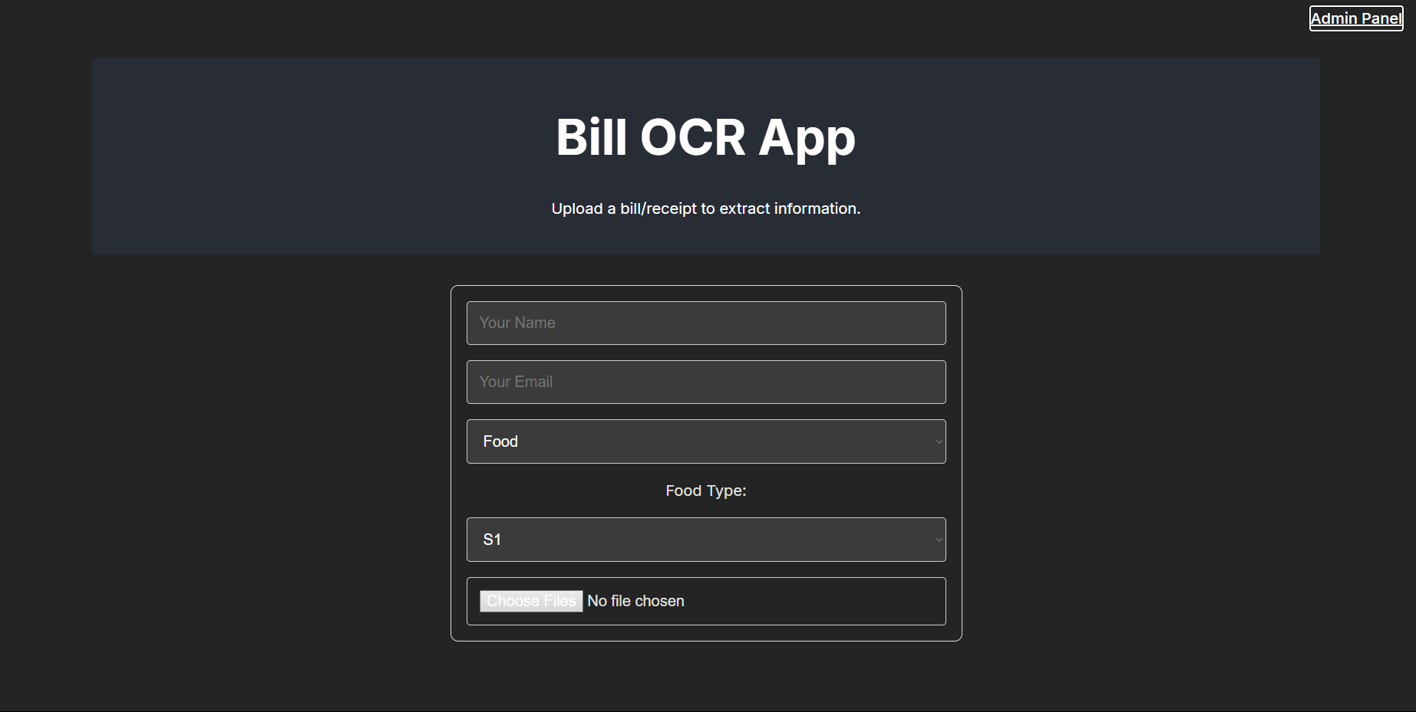
Figure 1
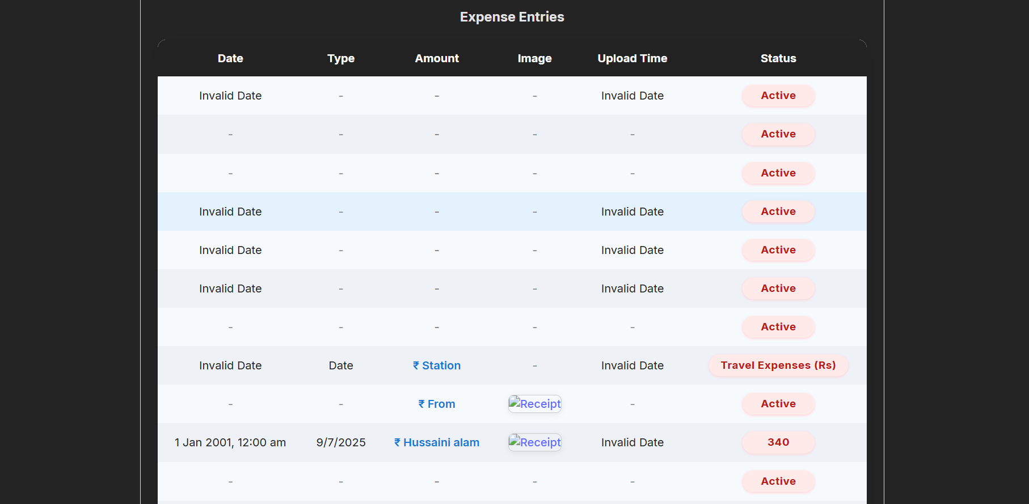
Figure 2
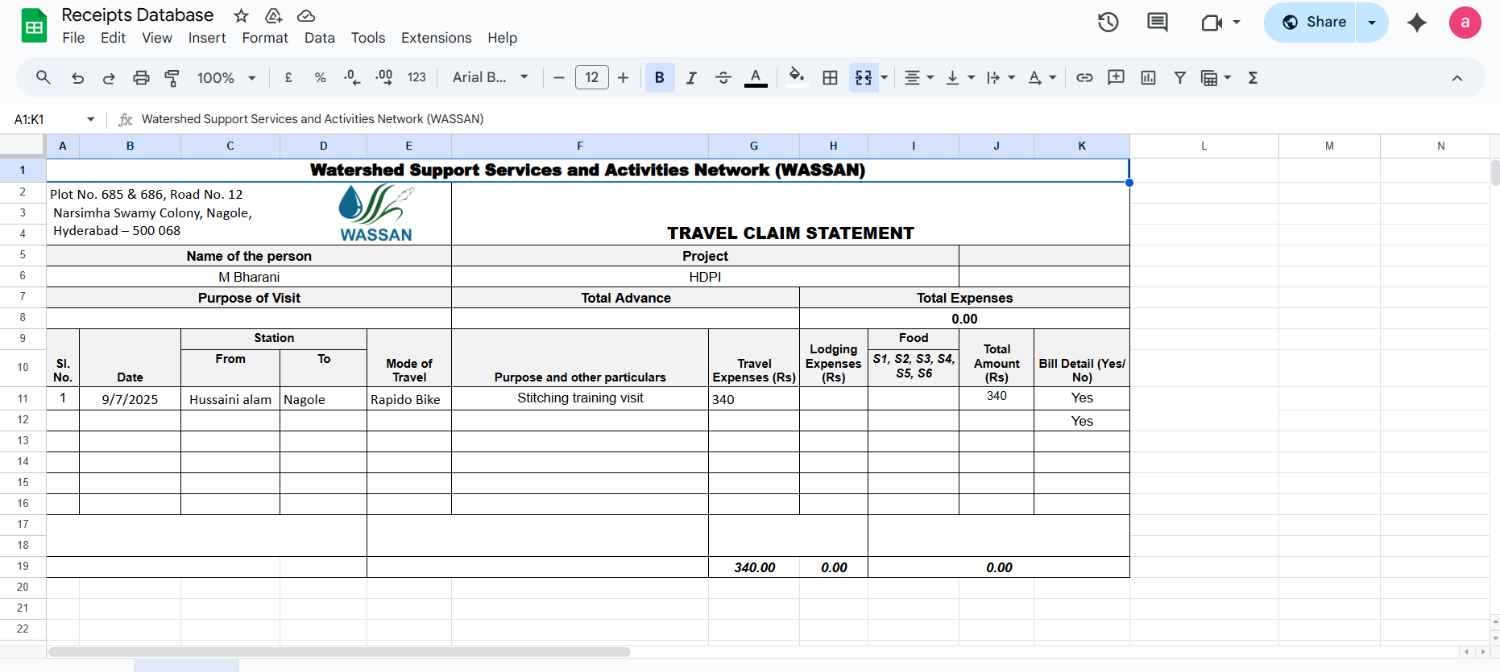
Figure 3

Fig 5.1 MAA NAVA LOKEM WEBSITE

INTERFACE

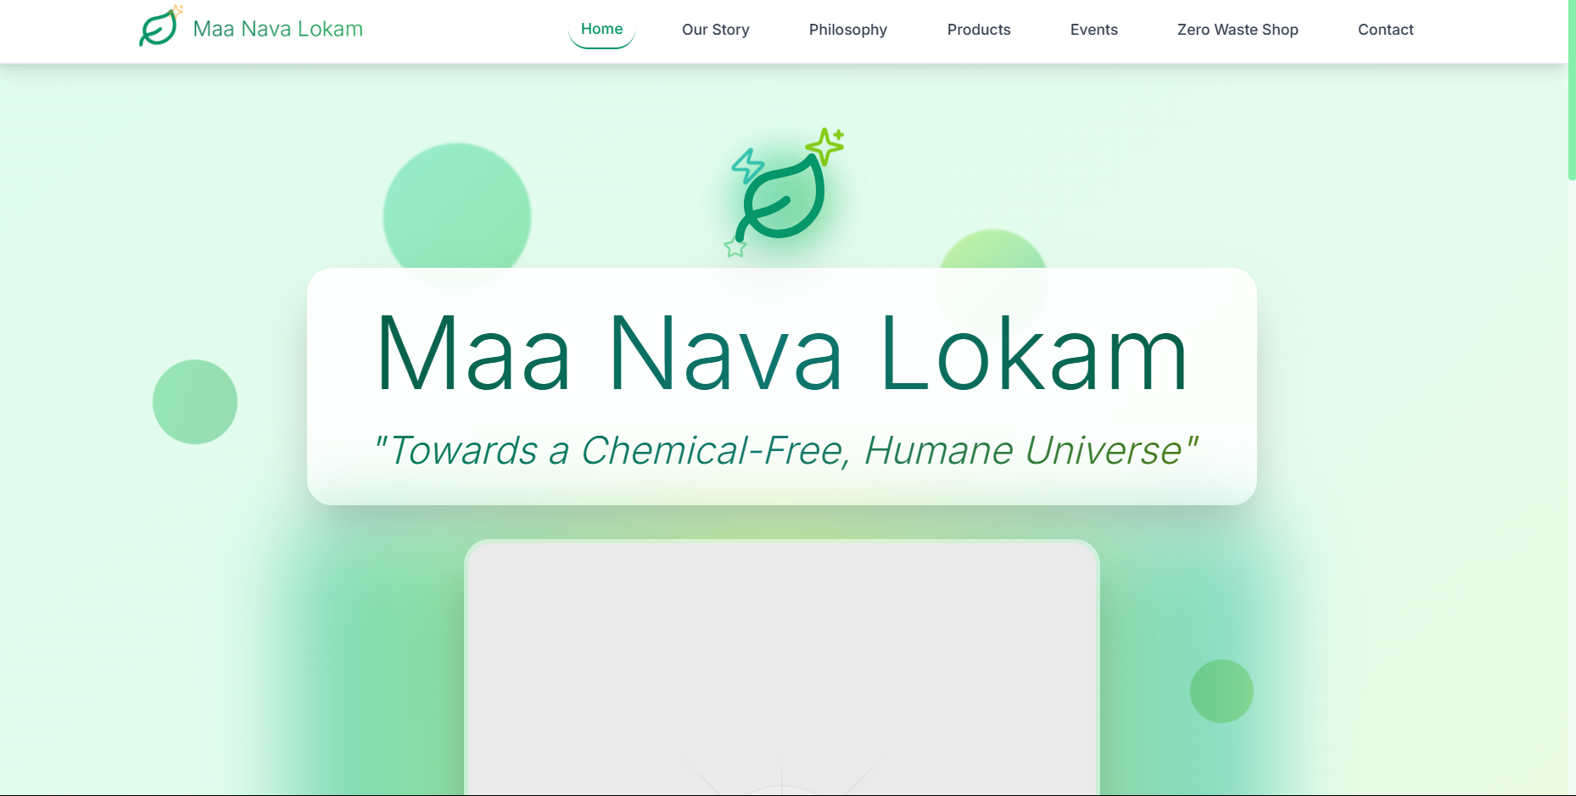
Figure 4
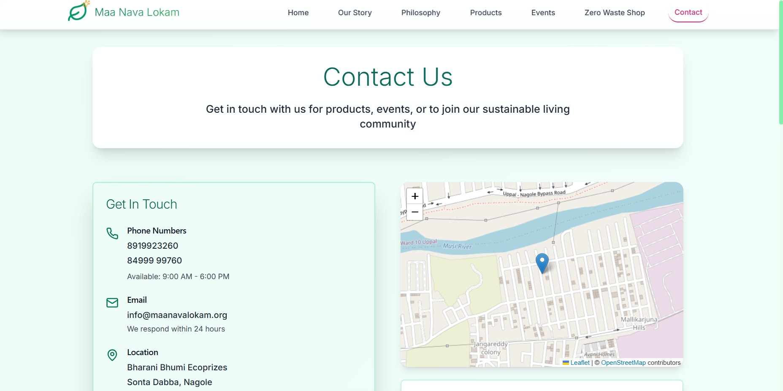
Figure 5

Fig 5.2 SCRIPT (CODE)

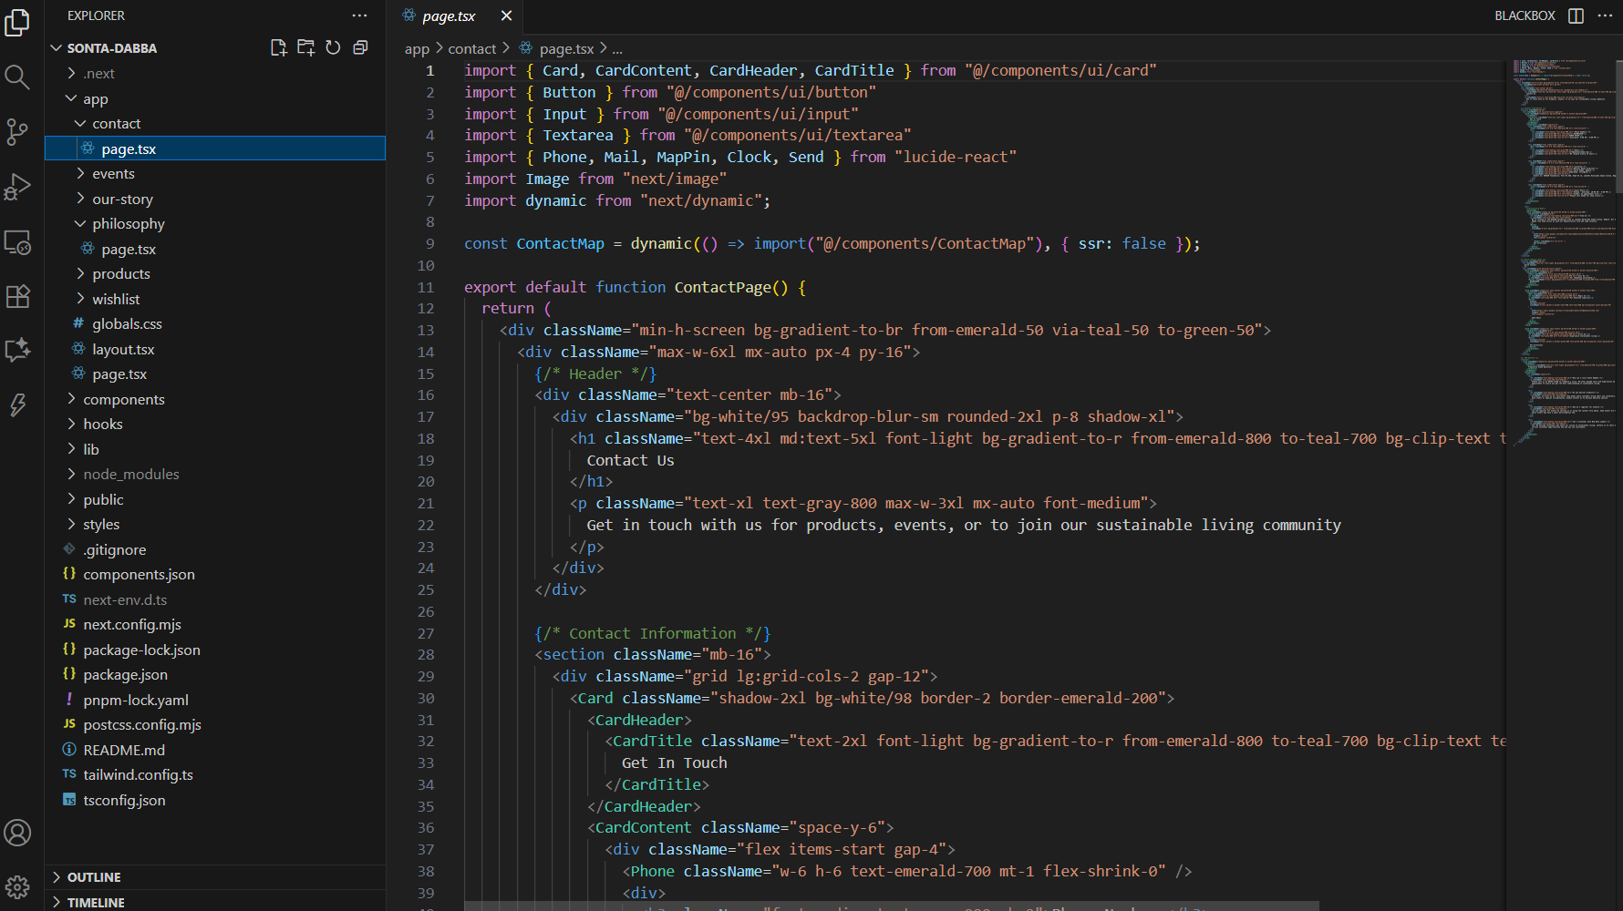
Figure 6

WASSAN FOUNDATION WEBSITE
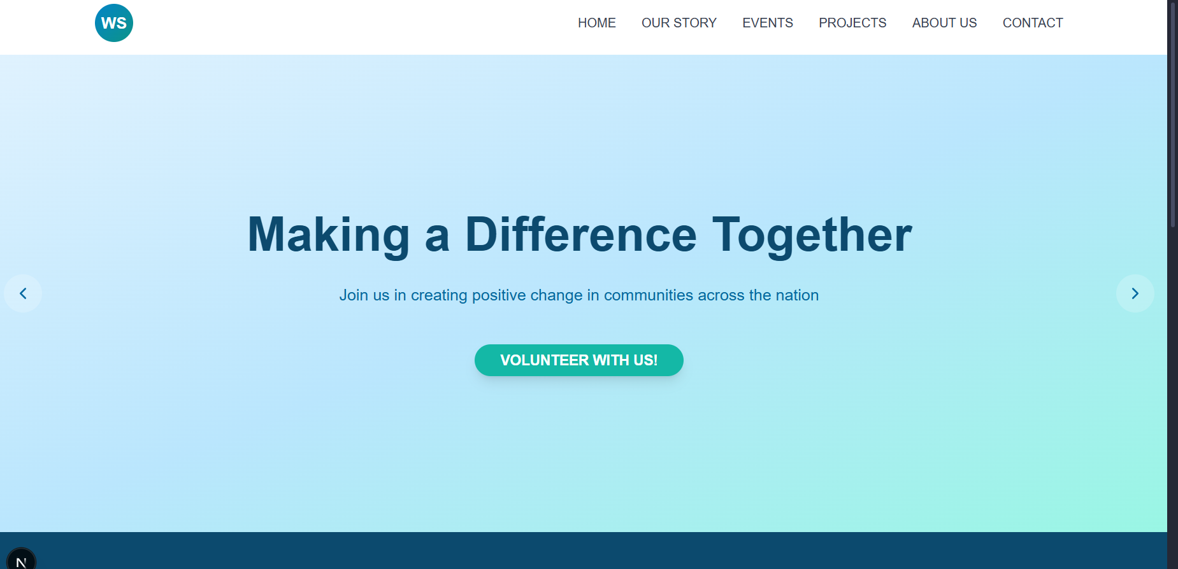
Figure 7
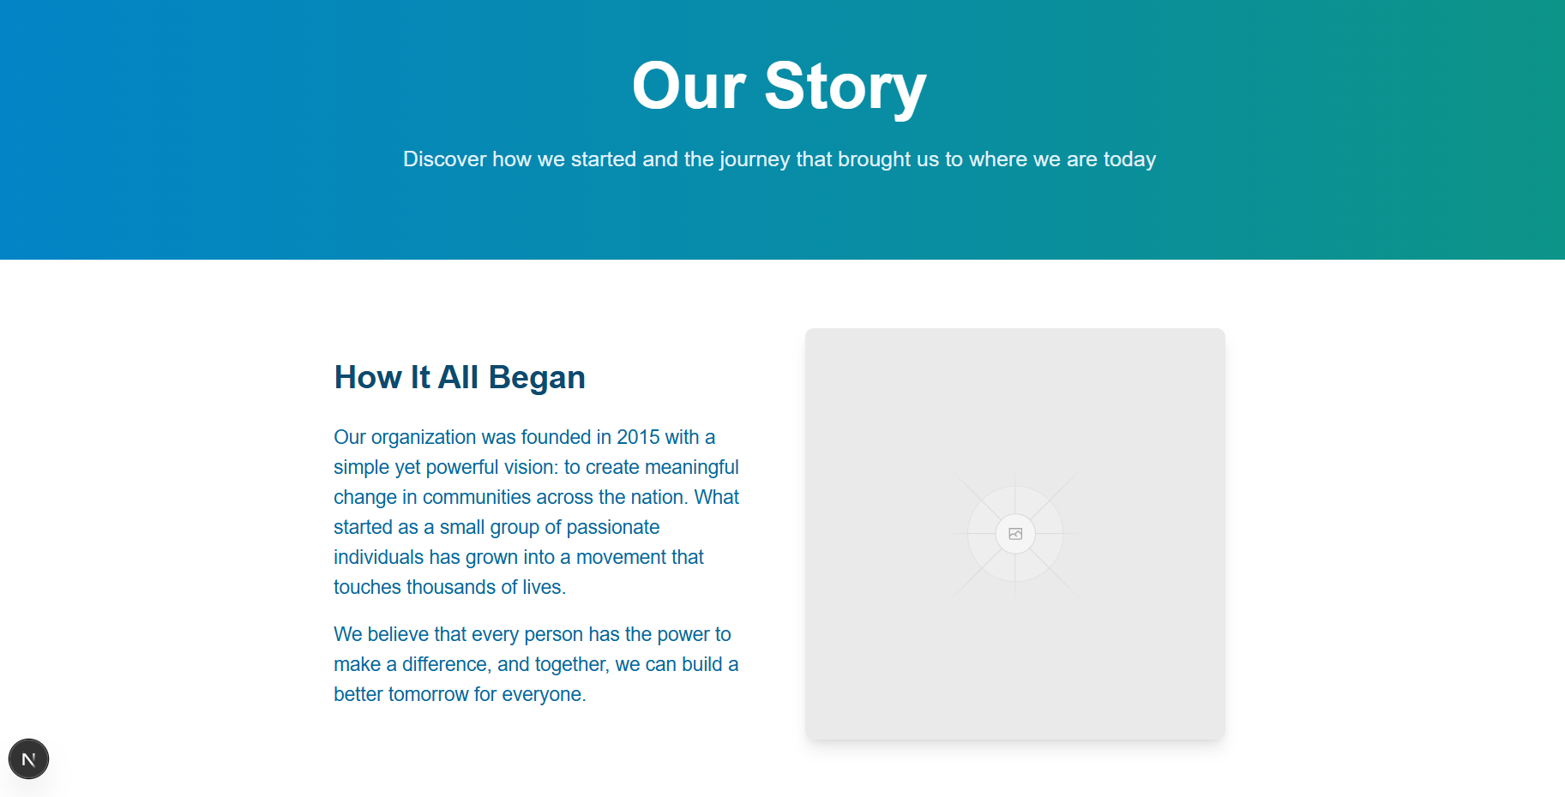
Figure 8

Fig 5.3 SCRIPT (CODE)

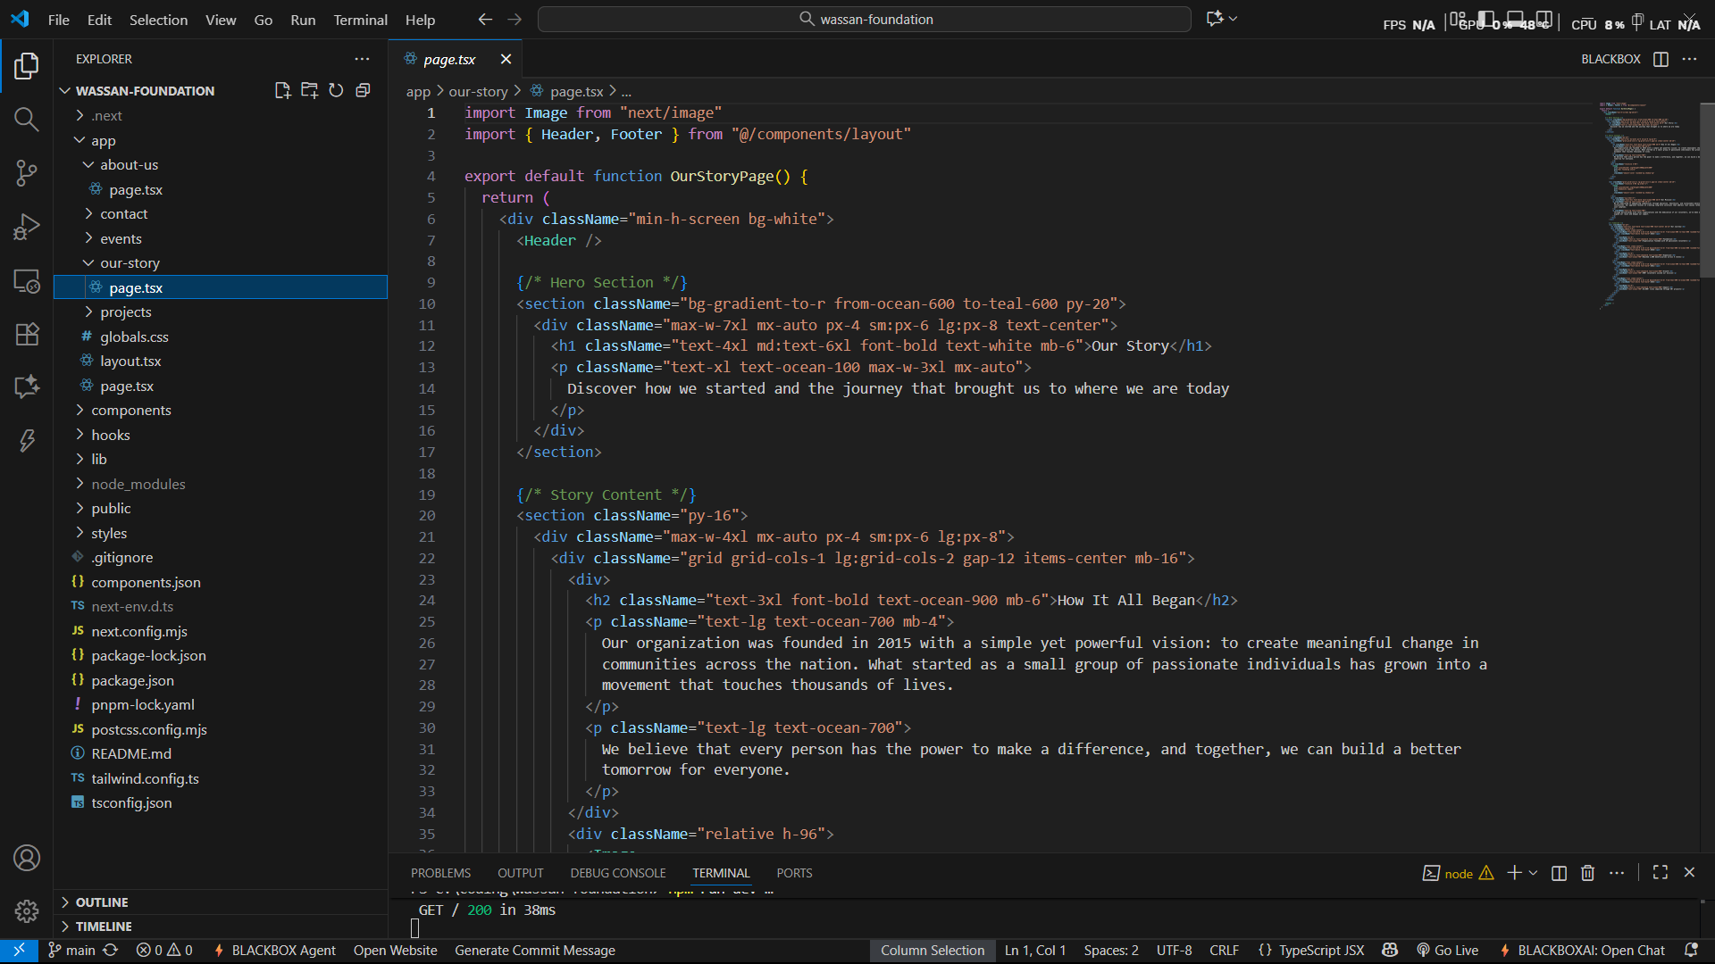
Figure 9
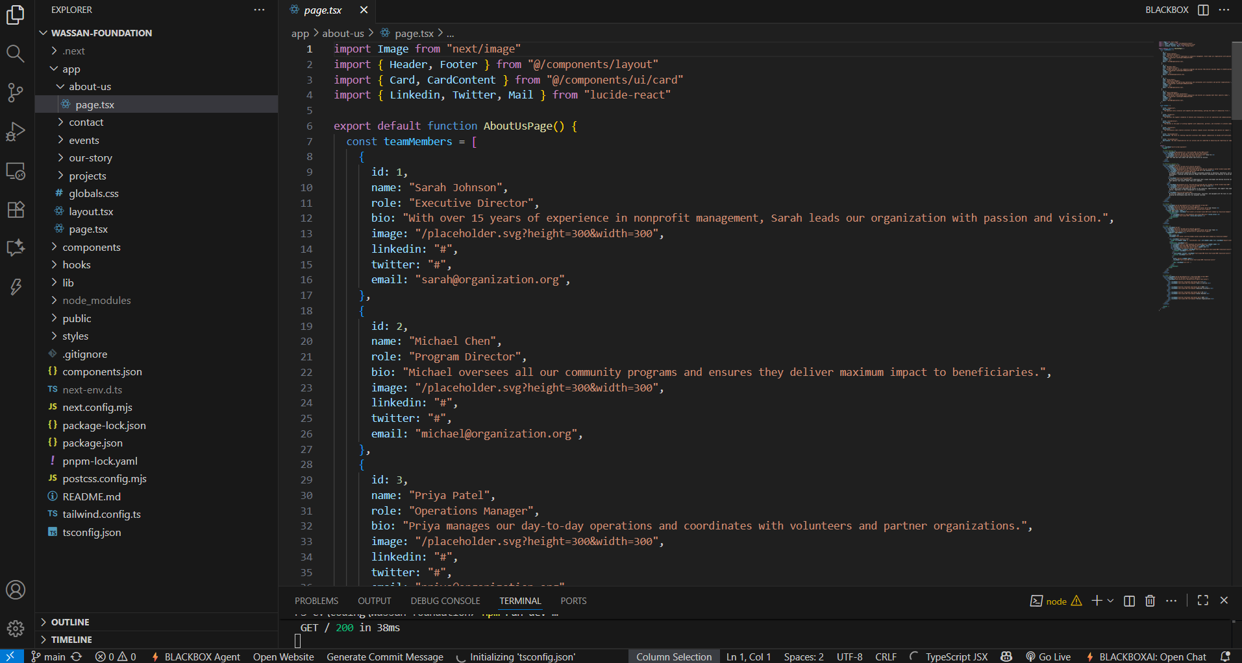
Figure 10

CHAPTER 6 RESULT AND DISCUSSION
The implementation of the digital solutions for the Wassan Foundation yielded a substantial improvement in administrative efficiency and overall project outcomes. The Bill Management Module successfully automated recurring financial tasks, reducing manual data entry time by nearly 70 percent. Staff testing demonstrated that the OCR system’s accuracy exceeded initial benchmarks, with consistent recognition of numeric and text-based values from scanned bills. The integration with Google Sheets enabled centralized access to expense records, improving financial transparency and collaborative accountability among different departments. This module proved instrumental in cutting down delays associated with report preparation and financial reviews.
The redesigned Wassan Foundation website received highly positive feedback from both internal stakeholders and external users. Enhanced navigation, responsive design, and optimized content delivery improved the accessibility of information related to the NGO’s programs, ongoing initiatives, and volunteer opportunities. Analytics data showed a 50 percent increase in user traffic within the first few weeks of deployment, along with longer session durations, indicating improved user engagement. Moreover, the ability to showcase success stories and impact reports online strengthened donor relations and increased community awareness of the foundation’s sustainability programs.
The community website module, developed under the “Sonta Dabba Manava Lokkam” initiative, achieved its goal of creating a digital hub for sustainable lifestyle promotion. Testing phases highlighted the portal’s efficiency in delivering educational materials and promoting environmentally conscious living. Interactive design elements enabled effective knowledge exchange between rural farmers and urban sustainability advocates. The integration of secure authentication and role-based access control ensured that sensitive data remained protected while maintaining inclusivity for verified users.
From a broader perspective, the systems implemented under this project demonstrated how digital transformation can amplify social impact in non-profit organizations. The project bridged gaps between technology and field-level engagement, enabling the NGO to function more transparently, efficiently, and inclusively. Overall, the digital solutions not only enhanced operational performance but also reinforced the NGO’s long-term mission of supporting sustainable agriculture, natural farming, and community development. The results affirm that strategic use of technology can substantially empower NGOs to scale their outreach and improve data-driven program delivery..

CHAPTER 7 CONCLUSION
The digital transformation project implemented for the Wassan Foundation has successfully demonstrated how technology can significantly enhance the operational efficiency and outreach capabilities of non-profit organizations. By automating critical administrative tasks such as bill management and financial tracking, the NGO has been able to reduce administrative overhead and redirect resources toward its core mission of promoting sustainable agriculture and community development. The newly developed digital platforms have also broadened community engagement, making crucial information and educational resources more accessible.
Feedback from NGO staff and beneficiaries indicates improved transparency, streamlined workflows, and a heightened sense of collaboration across diverse stakeholder groups. The redesign of the Wassan Foundation website and the introduction of interactive community portals have not only elevated the NGO’s visibility but also fostered stronger connections with donors, volunteers, and local communities. These improvements contribute to building trust and encouraging greater participation in sustainability initiatives, which are essential for long-term impact.
Looking ahead, the modular and scalable design of the implemented digital solutions provides a robust foundation for future enhancements. Plans for incorporating advanced features such as real-time data analytics, mobile applications, and AI-driven insights will further empower the NGO to respond dynamically to evolving community needs. Additionally, expanding training and capacity-building initiatives will ensure continuous adoption and maximization of technological benefits.
In summary, this project illustrates the transformative potential of integrating digital tools within non-profit operations, ultimately advancing social, environmental, and economic outcomes. The success of Wassan Foundation’s digital transition serves as a replicable model for other NGOs aiming to leverage technology for greater impact and sustainability. Continued investment in digital infrastructure and strategic innovation will be key to meeting future challenges and scaling the foundation’s positive contributions to rural communities.

COMMUNITY WORK RELEVANCE TO NGO

The Wassan Foundation’s core mission revolves around empowering rural agricultural communities through sustainable farming practices and environmental conservation. This project’s community-focused digital interventions directly support that mission by providing tools that enhance knowledge dissemination, enable efficient resource management, and build stronger community networks. By addressing operational inefficiencies and expanding digital accessibility, the NGO’s engagement with farmers and local stakeholders is markedly improved, allowing for more inclusive and impactful outreach.
The bill management system specifically benefits the community by ensuring transparent and accountable financial practices within the NGO, thereby building trust among donors and beneficiaries. A more transparent financial ecosystem encourages community members to actively participate and contribute to programs, knowing that resources are effectively managed. Furthermore, accurate expense tracking ensures that funds are optimally allocated towards community development initiatives, including training farmers in natural farming techniques and promoting sustainable livelihood programs.
The redesigned and new community websites serve as reliable platforms for education and awareness, making critical information on chemical-free agriculture, natural farming, and environmental well-being easily accessible. These platforms act as bridges between the NGO and diverse community members, fostering knowledge exchange, encouraging dialogue, and promoting collective action towards sustainable development. The digital presence helps attract urban audiences and supporters, linking them with rural communities and amplifying the NGO’s impact far beyond geographical limitations.
Overall, the project’s community-centric approach reinforces the foundational values and objectives of the Wassan Foundation. It exemplifies how digital empowerment can serve as a catalyst for social change, enabling the NGO to fulfill its commitment to environmental stewardship, rural upliftment, and sustainable agriculture. Through technology-enabled community work, the NGO is better positioned to address contemporary challenges and nurture resilient, self-sufficient communities.

EXPECTED DELEVERABLES

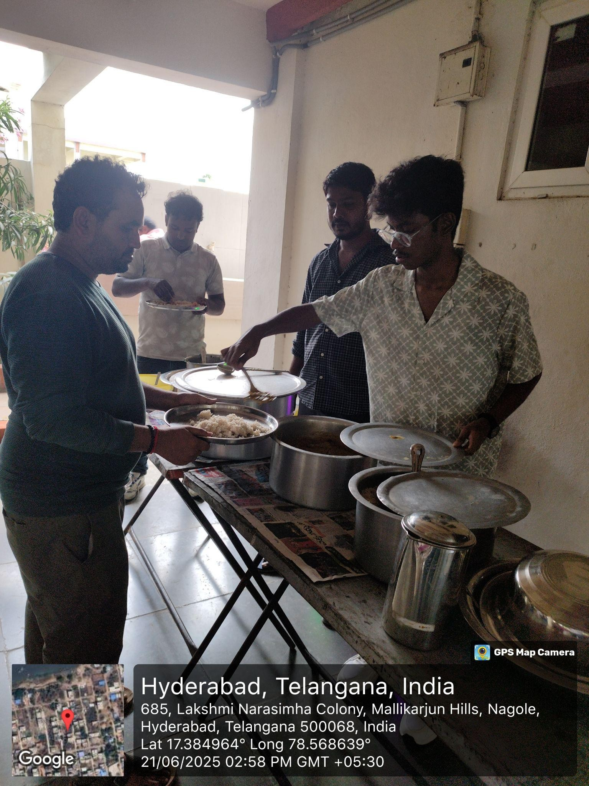
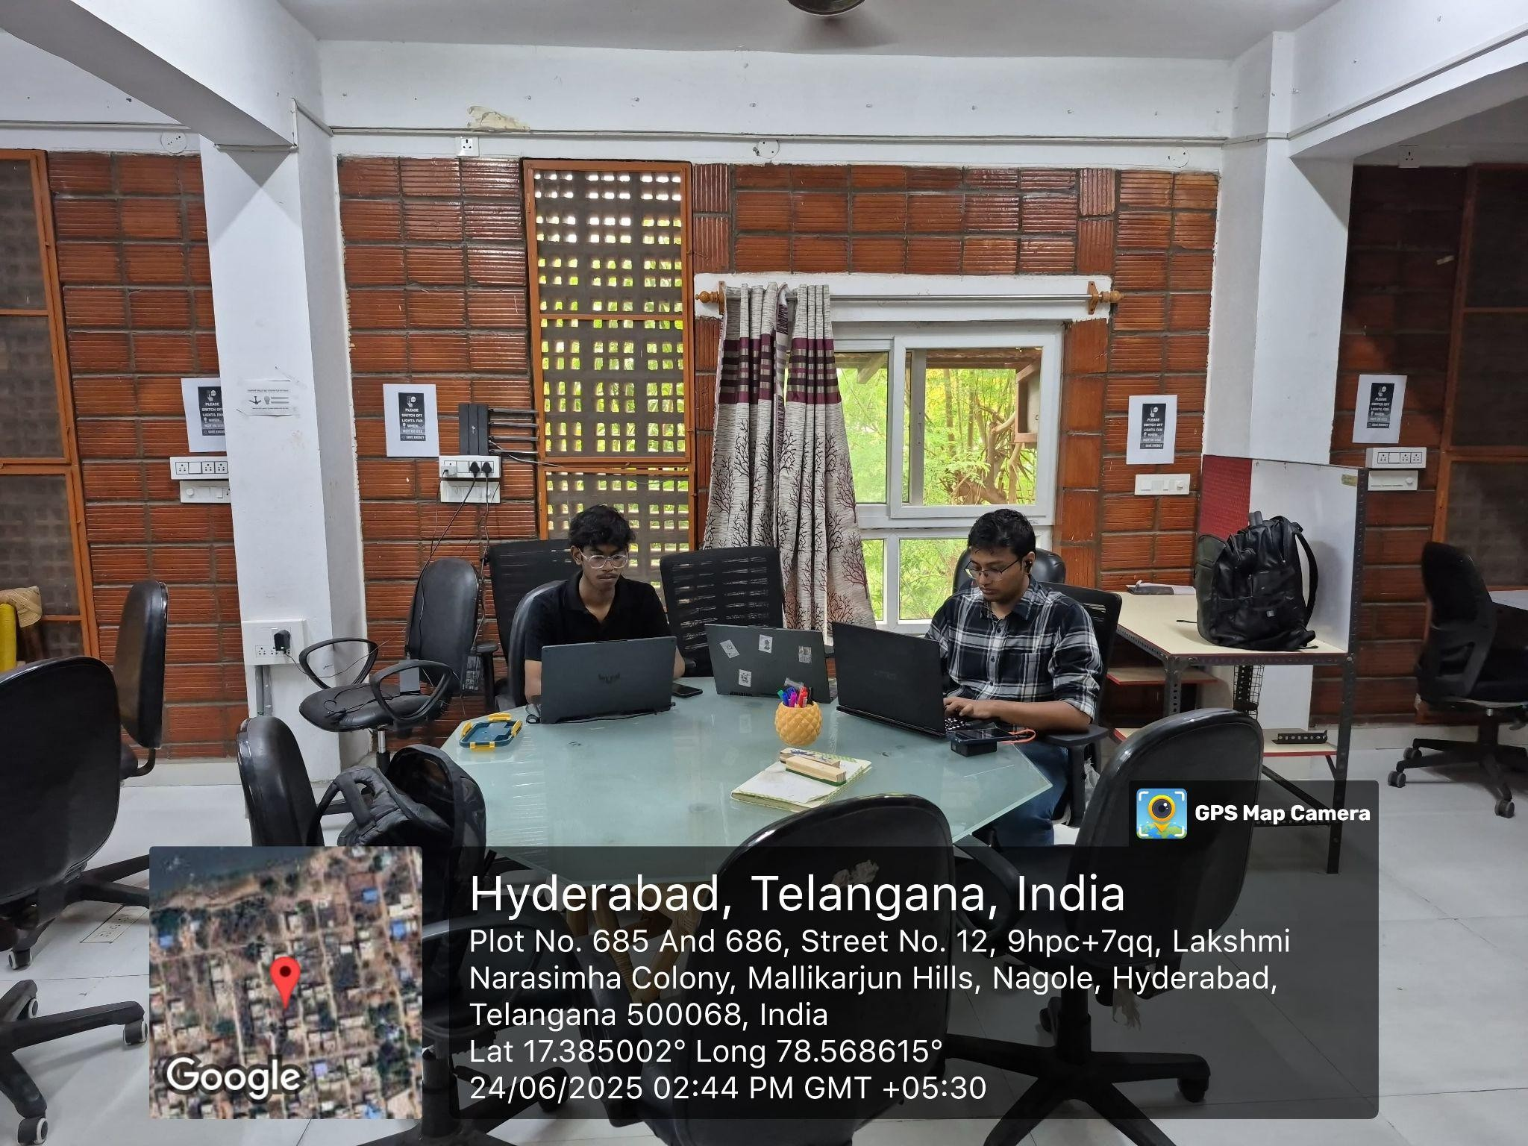

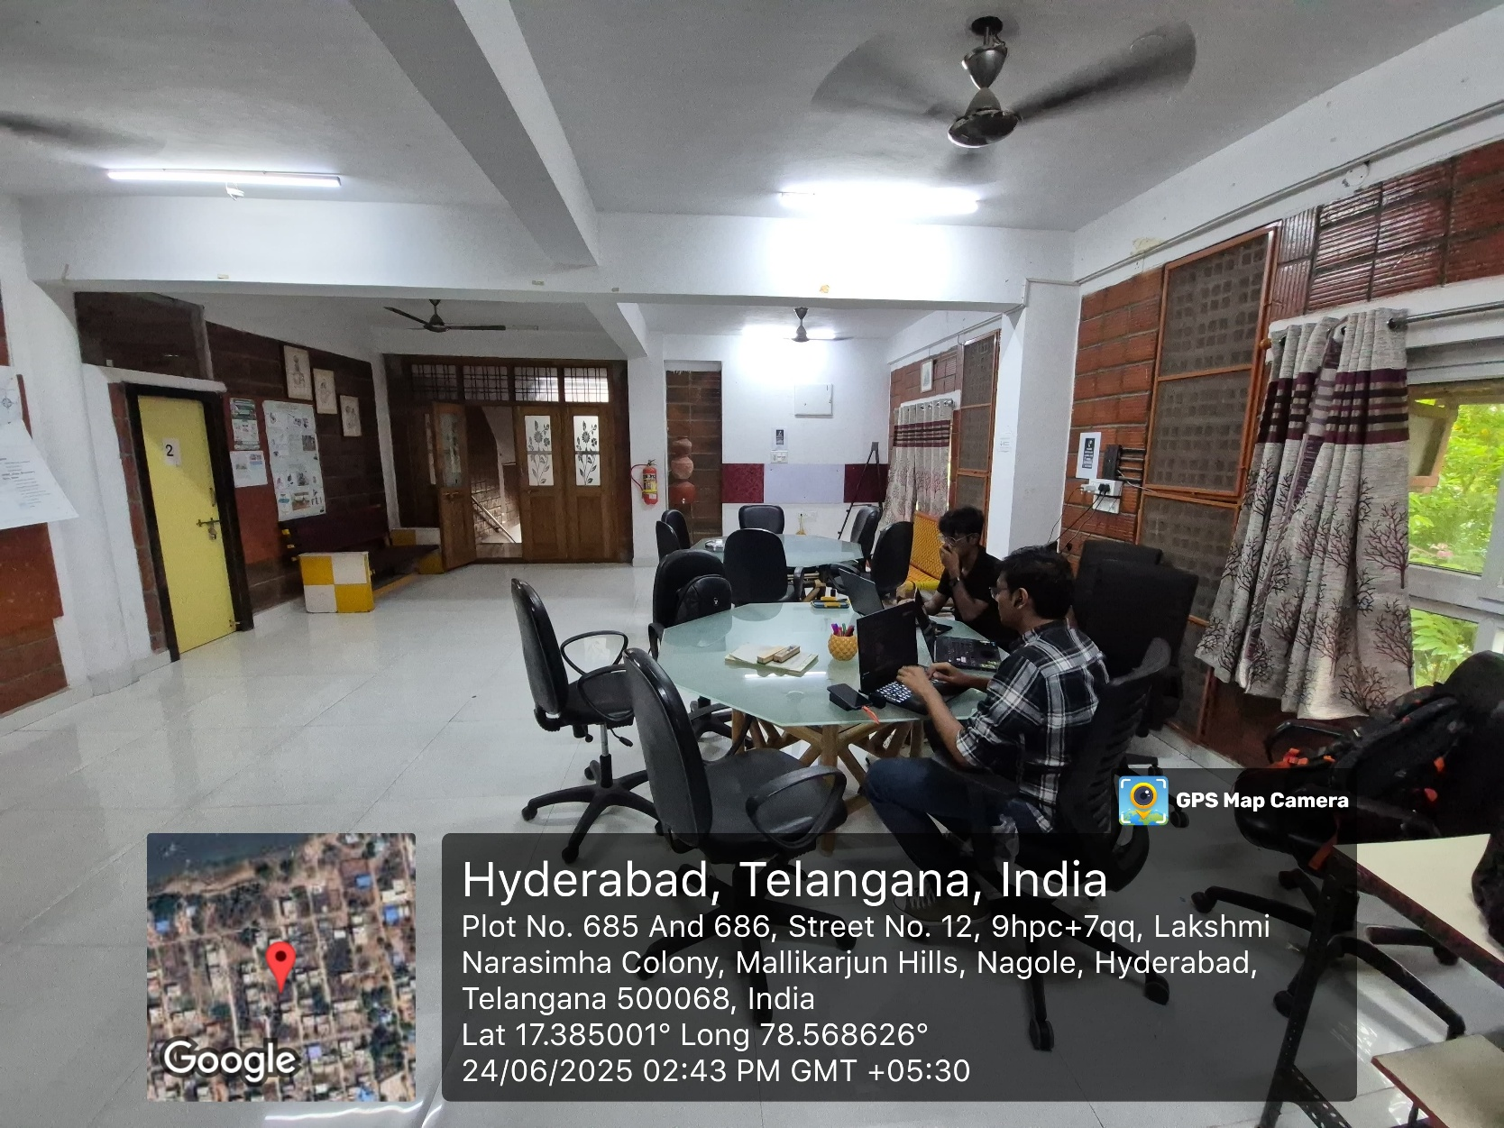

PROPOSED BUDGET

Sl.No. | Equipment/facilities | Qty. | Total (in Rs) | Justification
1 | Development Tools &  Software Licenses | 1 | 25,000 | Web development frameworks, OCR APIs
2 | Cloud Hosting & Domain  Services | 1 YR | 20,000 | Website hosting, domain registration
3 | Google Workspace Integration | 1 YR | 15,000 | API access, additional storage
4 | Testing Devices & Equipment | SET | 10,000 | Mobile devices, tablets for testing
5 | Field Visit & Documentation | - | 30,000 | Travel, accommodation, documentation
6 | Training & Support Materials | - | 10,000 | User manuals, training resources
 | Grand Total |  | 1,10,000

CONCLUSION AND FUTURE WORK

The project has conclusively demonstrated the transformative impact of digital technology in elevating the operational efficiency, transparency, and community outreach of the Wassan Foundation. The deployment of integrated digital platforms—ranging from financial management systems to community engagement portals—has enabled the NGO to function more effectively and to prioritize grassroots development, environmental conservation, and sustainable agriculture. The success of these solutions affirms that strategic adoption of digital tools can amplify social impact, foster stakeholder collaboration, and support long-term sustainability goals in rural and marginalized communities.

Building on these achievements, future work will focus on expanding the digital ecosystem by scaling solutions to other NGOs within the Rainfed Areas Network (RRA). Developing mobile applications tailored for field workers will facilitate real-time data collection and community interaction, especially in remote areas with limited connectivity. Additionally, integrating AI-powered insights can enable predictive analytics, optimize resource allocation, and support data-driven decision-making processes, further strengthening community resilience and climate adaptation strategies.

Finally, the future of this project lies in continuous innovation and adaptive scaling. Establishing collaborations with government agencies, academic institutions, and private sector partners will foster ecosystem-wide synergies for sustainable development. Emphasizing capacity building and technological inclusivity will ensure that digital transformation remains accessible and impactful for all stakeholders. This ongoing evolution will secure the foundation’s relevance amid changing environmental and socio-economic conditions, ultimately contributing to a broader paradigm shift towards inclusive, sustainable, and tech-enabled rural development.

REFERENCES

    - FAO. (2020). Digital agriculture in action – Selected case studies from India. Food and Agriculture Organization.
    - CGIAR. (2022). Digital agriculture in action: Selected case studies from India. CGIAR Research Program on Policies, Institutions, and Markets.
    - ICT for Change. (2022). The Digital Ecosystem Opportunity for Indian Agriculture.
    - ScienceDirect. (2024). Digital transformation of the agricultural industry: innovations and challenges.
    - Wassan Foundation. (2022). Annual Report 2022-23. Wassan Foundation.
    - JEMI. (2025). Final analysis on digital transformation and its impact. International Journal of Public Resilience and Management.
    - Think20. (2023). Leveraging technology for rural community development.
    - FAO. (2019). Sustainable food and agriculture – A review. Food and Agriculture Organization.
    - World Bank. (2024). Digital Adoption for Inclusive Development.
    - NITI Aayog. (2021). Transforming India: Towards a Digitally Empowered Society. Government of India.

